
NORTHERN PIEDMONT RETRIEVER CLUB

Dedicated to promoting the skills and breeding of working retrievers.

A NAHRA Affiliated Organization

2005 Fourth Quarter Newsletter

PRESIDENT’S MESSAGE:

Season’s Greetings to Everyone!

2005 has been a fun, exciting, and busy year for NPRC! A quick review of the Calendar of Events table shows a Winter banquet and Summer picnic, nest box maintenance, a Spring and Fall test, a NFRA test, a judge’s clinic, a Fall upland hunt, and monthly training sessions that included many new formats. Thanks again to everyone for their help at all these events. Because of all of you, this is an easy club to lead.

Hopefully many of you have been enjoying the hunting season and especially the opportunities to hunt with your dog. While most hunting retrieves and situations are fairly easy, occasionally there are those times when a well-trained retriever makes us proud. Whether it’s that delayed double on pheasants, that long glider the dog doesn’t mark, or the time the dog gets caught in the decoys, goose in mouth, and has to remain steady while more geese work in, it’s very rewarding to see all the training pay off.

There are also those times when things don’t go exactly as we’d like, and we resolve to put more attention into the training to prevent future occurrences. Regardless, times spent with our dogs are some of the most enjoyable we have.

Don’t forget that the wintertime can be the best time to work on your training. Much obedience work begins in the home and there are always opportunities to work on that. Snow or darkness doesn’t need to stop you either because these dogs have excellent night vision and noses that can find bumpers (or tennis balls) buried in the snow.

As we look forward to the New Year, our Winter Banquet will be held on January 21st with training the next day. Details to follow! This is the time we talk about the upcoming year, develop direction for the club, and generally have a great time! Why don’t you all join us?

Have a safe and enjoyable holiday season and I hope to see all of you at the banquet, January 21st.

Merry Christmas and Happy New Year to everyone!

Jon

NPRC 2005 Fourth Quarter Newsletter Page 2

2005 NPRC OFFICERS

President: Jon Vernam 717-834-4074 email: jonvernam at yahoo dot com
Vice-President: Bob Andrews 610-473-2299 email: nitro1 at dejazzd dot com
Sec/Treasurer: Tom Johnston 717-444-3691 email: tkjohnston at pa dot net
Training: Frank Plewa 717-334-7135 email: swampcop at superpa dot net
Newsletter: Larry Housman 410-837-5873 email: lshousman at netzero dot com

Board of Directors

Dotty Waldrep 717-292-9158
Mike George 410-388-1570 email: ravenmaniac411 at comcast dot net
Jeff Riebling 717-630-9422 email: JeffRiebling at aol dot com
Bruce Jenkins 717-258-6197 email: scuzlbt at aol dot com
______________________________________________________________________________

CLUB SPONSORS


MIKE TOME

BRUNSWICK, MARYLAND

BRUCE JENKINS
BOILING SPRINGS, PENNSYLVANIA
______________________________________________________________________________

MEMBER UPDATES

Jackie Lutskus – new email: jlutskus390@comcast.net
Bob Bimeal – new email: bbimeal@atlanticbb.net

Please welcome our new members:
Bill Everly everly@zoominternet.net
Robert & Anne Kraybill iamafoxhunter@comcast.net
Sonny Jones jones341@cablespeed.com
Stephanie Elaine Andrews and Ashley Nicole Andrews

NPRC 2005 Fourth Quarter Newsletter Page 3

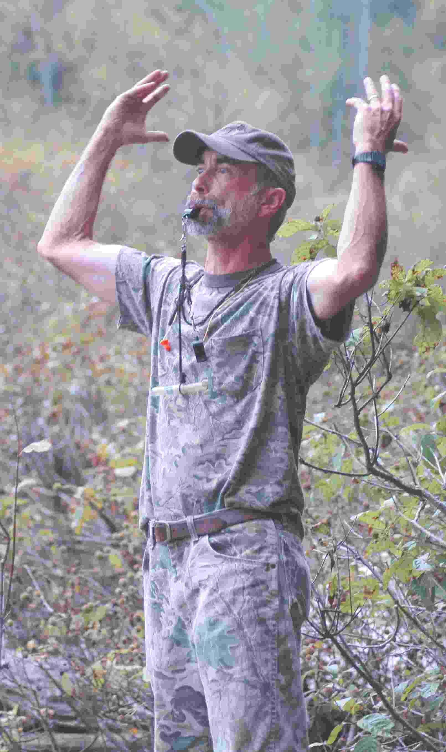
The agony and ecstasy of our fall test. Jon Vernam raises his arms in dismay at some sort of turn of events at the Senior I water series, while Diane Shepperd seems to be raising hers in a more celebratory gesture. (Both photos courtesy Betty Schmidt)

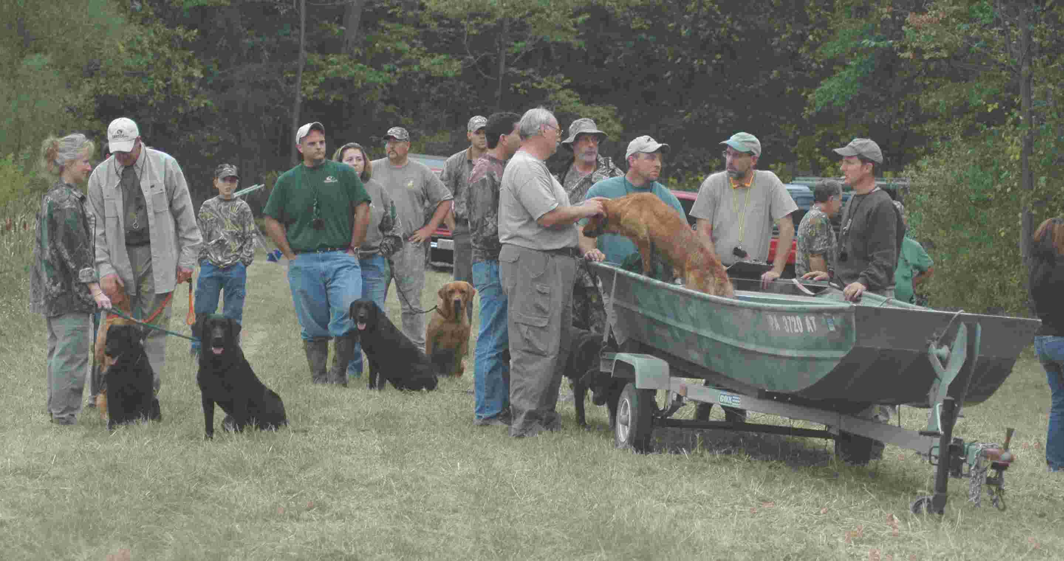
Late in the day Saturday, handlers line up to finish the Senior III trail. Note Bruce Jenkins cruelly twisting the ear of a Golden as Jeff Riebling distracts owner Doug Jaffee. I have no idea why Scott Leonescu is standing so close behind Bruce, nor exactly where his right hand is located, but I have heard they will be sharing a hotel room at the first test in the spring! The Combs’, Mike George and Larry Housman look on in disgust. (Photo courtesy Betty Schmidt)

NPRC 2005 Fourth Quarter Newsletter Page 4

UPCOMING EVENTS

January 21st – 5:00 PM – Annual Banquet – details elsewhere.

January 22nd – 9:00 AM -Training Session - State Game Lands #243, Franklintown, York County. Directions: Take Route 194 north from Hanover, or south from Dillsburg, as appropriate. Turn west on Franklintown Road, which is approximately 1 mile south of Franklintown. Turn right on Game Lands Road and follow signs to parking area.

February 12th – 9:00 AM -Training Session - State Game Lands #249, Heidlersburg, Adams County. Directions: Route 15 to Heidlersburg/Biglerville exit (PA Route 234). East on 234 approximately ½ mile to Gun Club Road on your left. Parking area is 1+ mile down Gun Club Road on your right.

February 18th – 19th – 8:00 AM –Annual Nest Box Maintenance - State Game Lands #249, Heidlersburg, Adams County. Directions: Route 15 to Heidlersburg/Biglerville exit (PA Route 234). East on 234 approximately ½ mile to Gun Club Road on your left. Parking area is 1+ mile down Gun Club Road on your right. Bring your waders, gloves and anything else you think we might need and join us. Will probably finish on Saturday, but may finish on Sunday the 19th if necessary. Contact Frank Plewa for further information.

March 12th – 9:00 AM - Training Session - Stewart Properties near Thomasville York County. Directions: (from Gettysburg) Go East on Route 30. After passing Biesecker Road (Light, approx. 20 miles), you will turn left on to Hidden Lane (and its hidden!) and follow it on to the farm. It’s a gravel road for the most part and dead-ends at the training area.

April 2nd – 8:00 AM - Training Session - Derek Smith Farm, Newport, Perry County. Directions: U.S. Route 322 west from Harrisburg to the Newport Exit (PA Route 34). PA Route 34 north ~1.0 mile to Bucks Valley Road (PA Route 1018). Right on Bucks Valley Road ~3.5 miles to Smith farm on left

April 7-9 – 8:00 AM – Spring Hunt Test - State Game Lands #249, Heidlersburg, Adams County. Directions: Route 15 to Heidlersburg/Biglerville exit (PA Route 234). West on Route 234 for approximately 2 miles and look for the orange NPRC signs.
_______________________________________________________________________

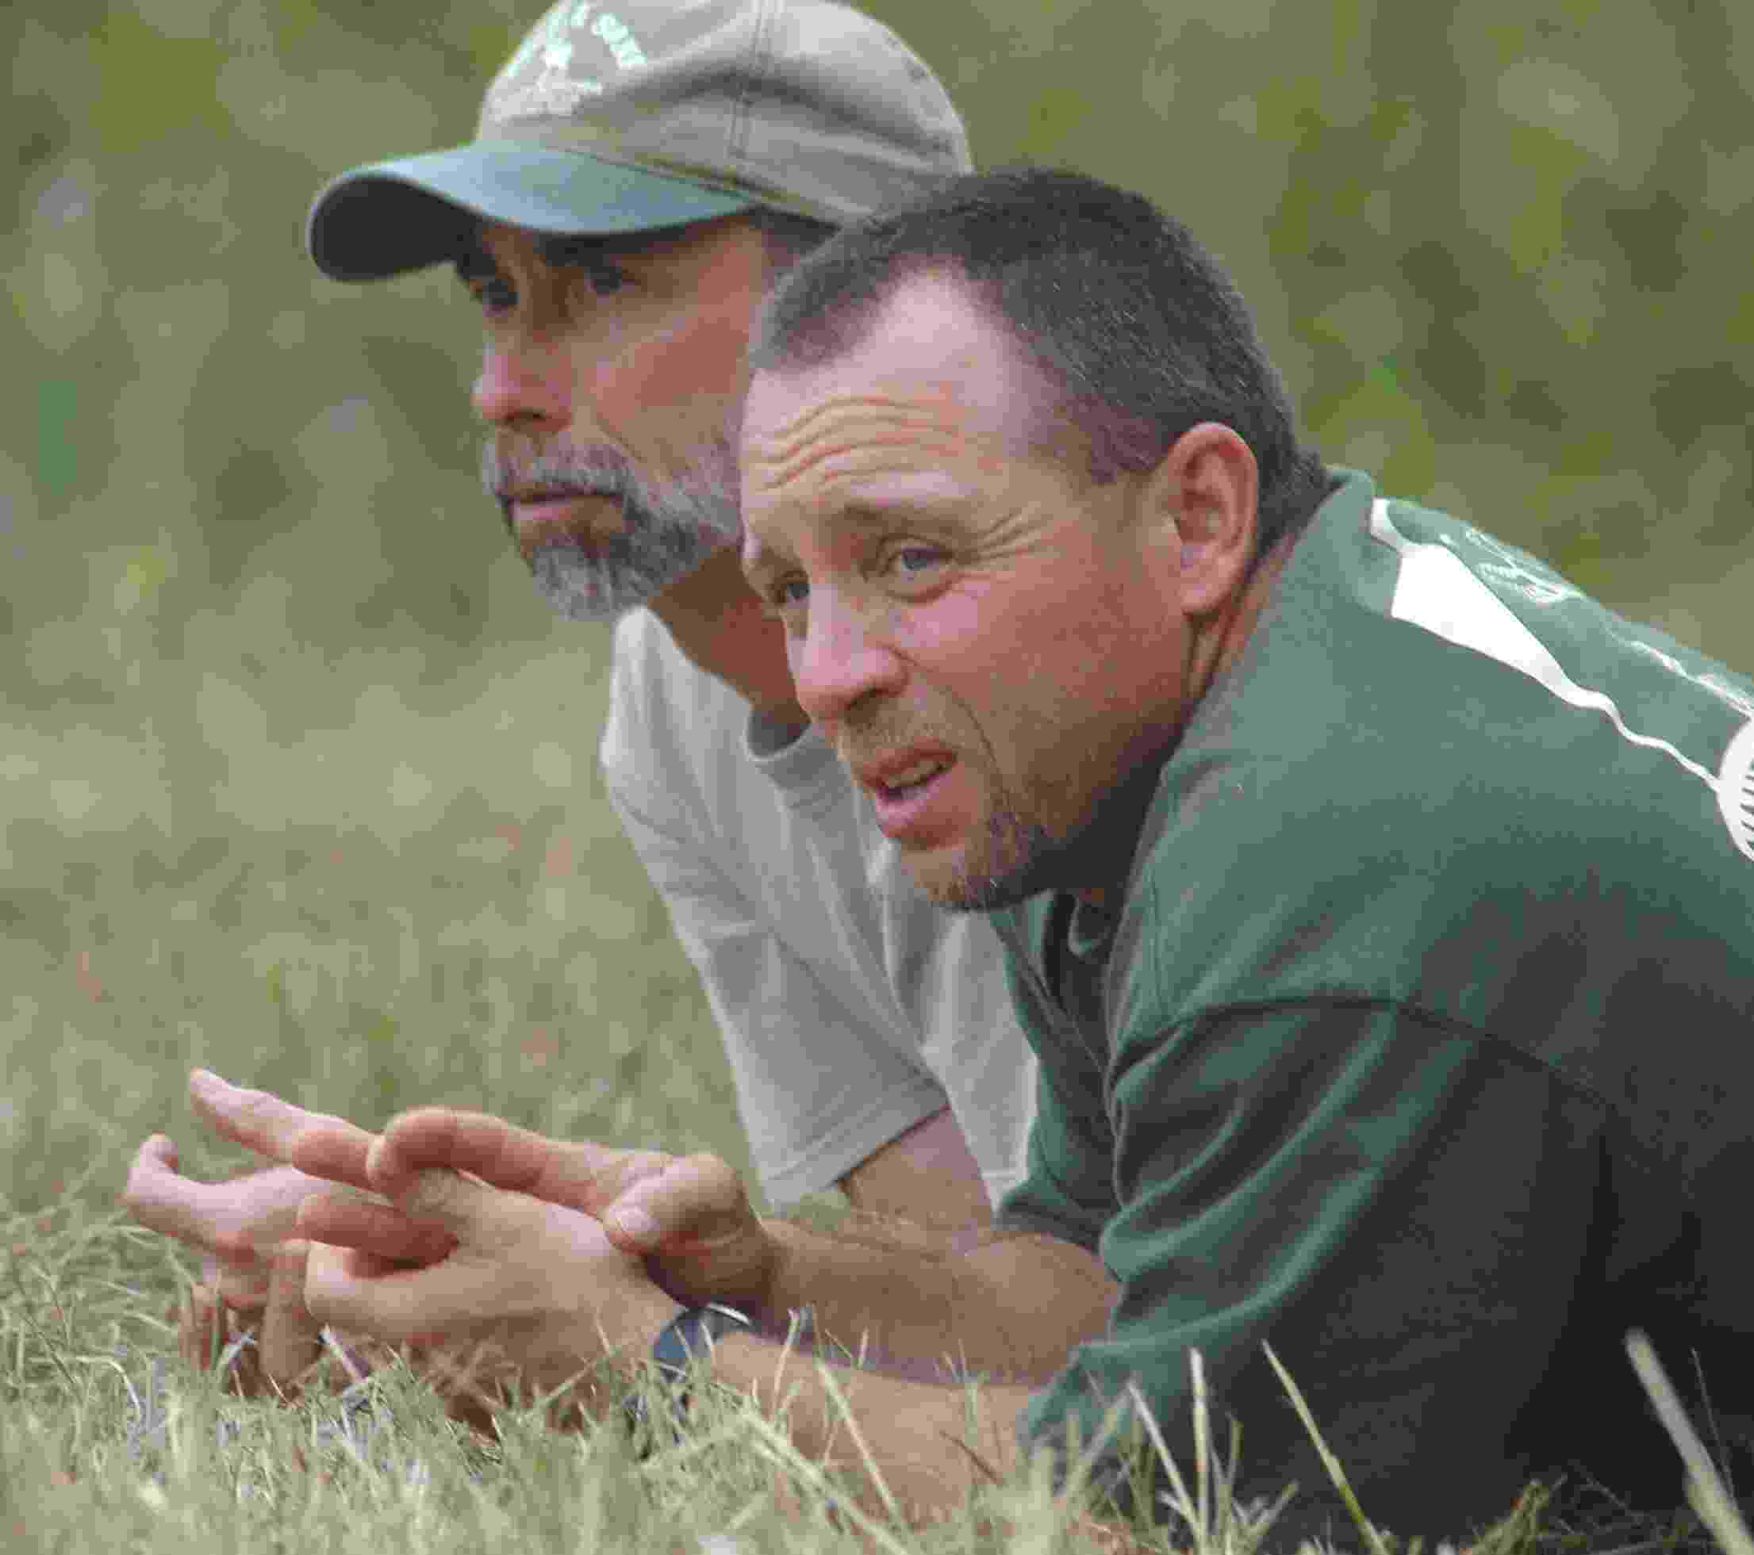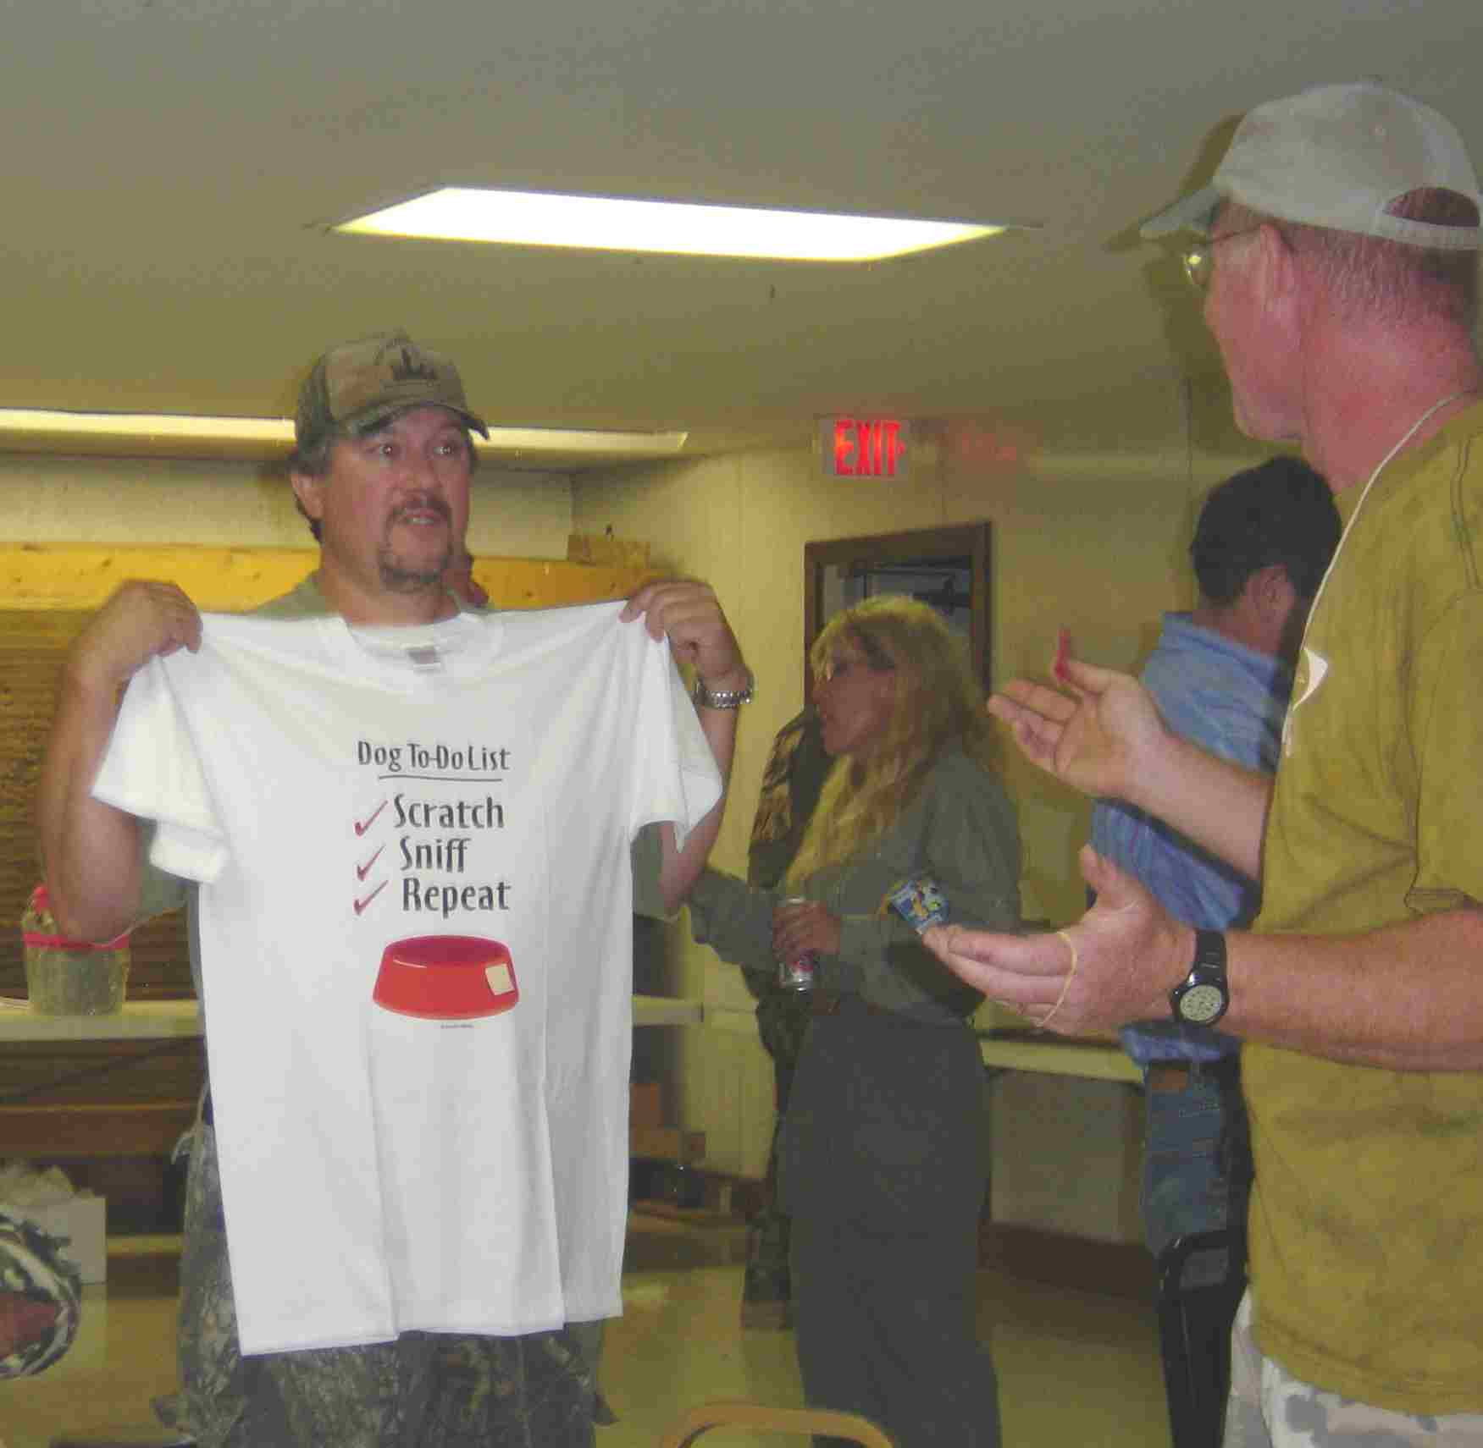
Still in shock, Jon and Jeff ponder what could possibly be up Showing less than his usual good grace, Mike Tome
with Scott and Bruce. (Photo courtesy Betty Schmidt) complains bitterly to Tom Johnston about his door prize.
(Photo courtesy Jackie Lutskus)

NPRC 2005 Fourth Quarter Newsletter Page 5

MINDLESS RAMBLINGS

First off, congratulations to Bob and Penny Andrews on the birth of Stephanie Elaine and Ashley Nicole on October 30th. From the early pictures, I’m sure you are as relieved as I am that they seem to take after Penny’s side of the family. That will keep them from scaring the dogs out in the field when they get old enough to throw marks, as so frequently happens now with Dirt Bob!
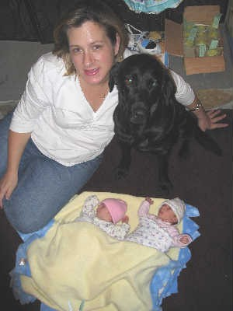

* * * * * * * *

I thought our fall test was one of our best ever, and I say that after going 0 for Senior with The Goon. Great judges, and it was especially nice to have Bob Riggs in from Iowa and Travis Lund from Minnesota as well as Paul Young back judging NAHRA again. Kudos to Frank for putting together a good slate. I’ve always felt that if you can flunk somebody’s test, but have fun doing it and look forward to running under him or her again, then you are in the presence of a great judge. I’m now 0 for 2 with Dave Ingham, but we’ll get him next time! (Actually we passed his and Bob’s Intermediate, but that doesn’t quite count – I think it was a mercy pass after they picked up on my suicidal tendencies and Frank told them he didn’t want to get in trouble with the Game Commission if they had to haul out my dead body!)

I know a bunch of folks got titles, and I’ll try to get an updated list for the next newsletter. Off the top of my head, I know Mike Minchoff and Gauge got their SR title, and Jon Vernam and Lea got their MHR. Dave Combs had a good weekend, although I’m not sure which of his pack got which title, but I think it was multiple MHR’s.

Financially we had a good weekend, due primarily to great raffle sales. Special thanks to Jon Vernam, who refused to let Senior I handlers go down to the site of the water series without hearing his spiel, and most especially to our own Bruce “light loafers” Jenkins, who won the Bennelli, then sold it to his little buddy Scott, then donated the money back to the club. Performing such a selfless act as that really makes me feel bad that I have an obligation, as a journalist, to point out his new predilections.

NPRC 2004 Fourth Quarter Newsletter Page 6

MINDLESS RAMBLINGS (continued)

This year’s banquet and annual meeting is scheduled for Saturday, January 21, 2006. Happy hour will begin at 5:00 PM, and dinner will be served around 6:00 PM. It will once again be held at the Manchester Café in York County. Please contact Tom Johnston with your entrée selection (Beef or Chicken) no later than January 14, 2006. Please bring a small door prize donation if you wish.

Directions: North on I-83 to Rt. 238, old exit 11. Turn right at exit, then left at first light. You will be on Route 181 north. The Manchester Café is approximately 2 miles on your left, across the street from the Sheetz gas station. The address is 4302 N. George Street Ext, Manchester, PA 17345. Phone is 717-266-3887.

Please make every effort to attend. If one of our teams is in the playoffs at the same time, we’ll get a TV in there somehow. We have a bunch of things to discuss, including what appears to be a very ambitious test schedule, and it’s always better to have as many of us as possible expressing our views.

* * * * * * * *

As I’m sure you’ve all heard by now, Jeff Smith is out as NAHRA President, and Jim VanDerGessien is in, at least on a temporary basis. Jeff did a great job of moving the organization forward, out of the depths of the rubber duck follies, and I doubt we’d be as well off as we are now without his work. Even though he may not get any credit for it, I’m very pleased to see that the Mid-Atlantic is apparently back in business again, after dropping off the face of the earth last year. In 2005 they only had two tests all year, not including the Benefit, and one of those was an unadvertised stealth test that I didn’t even know about until I saw the results posted. But in 2006 they have a full slate of tests in February, March and April, with hopefully more to come later in the year. There is a new club in the Virginia Beach area, and Shenandoah Valley is doing another test this year, after I feared that last year would have been it for them. So please try to support as many of these tests as you can. If these clubs are trying to resurface with tests, and end up losing their shirts because of poor attendance, they are not likely to be able to try again. They will either fold entirely, or move to another program – neither of which is a good option for NAHRA. They are early in the year, and that means our dogs won’t have as much water work as we’d like, but I think that over the years the judges of early season tests have taken that into account, so don’t let the calendar scare you off. Try to make them if you can!

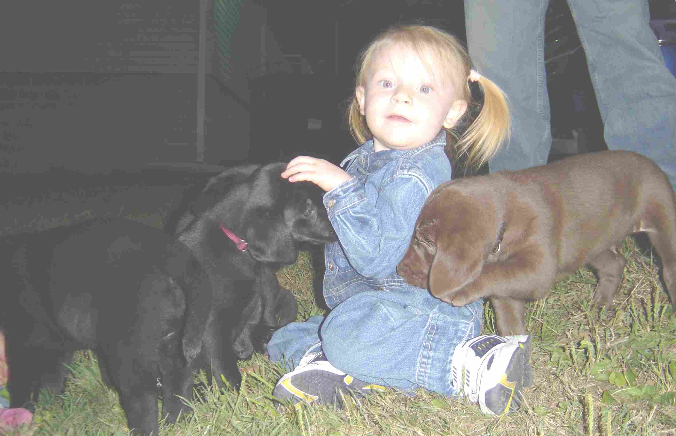
Natalie Patton keeps an eye on some pups while dad tends to his Secretary duties. (Photo courtesy Jackie Lutskus (I think!))
NPRC 2004 Fourth Quarter Newsletter Page 7

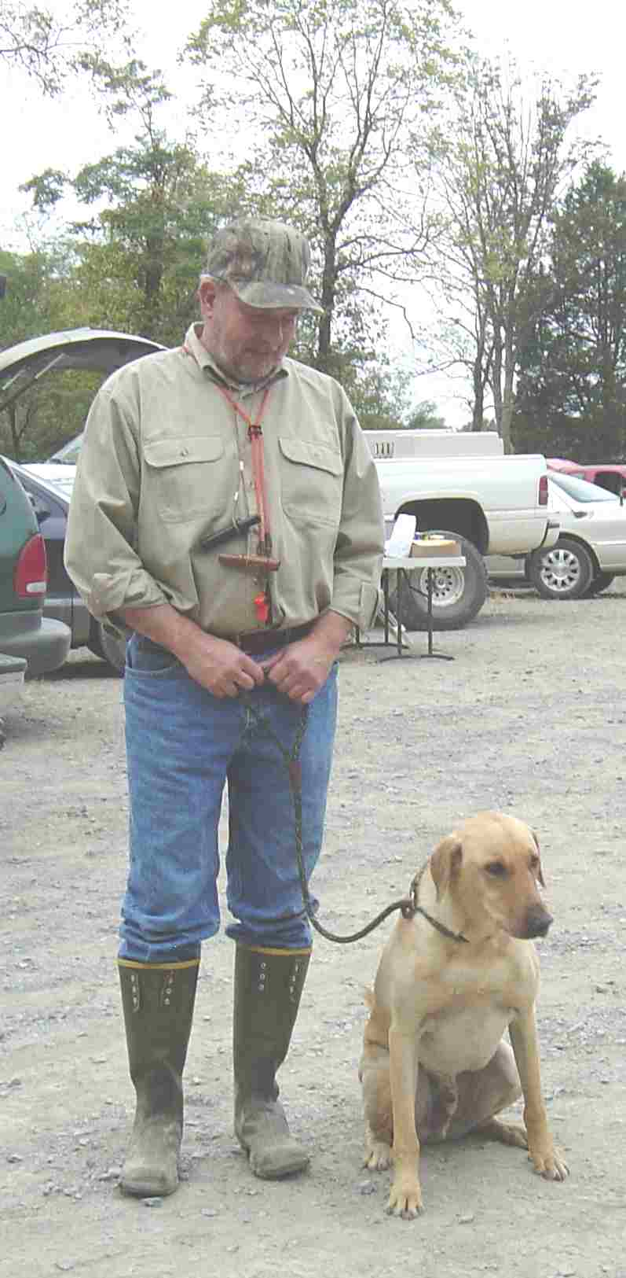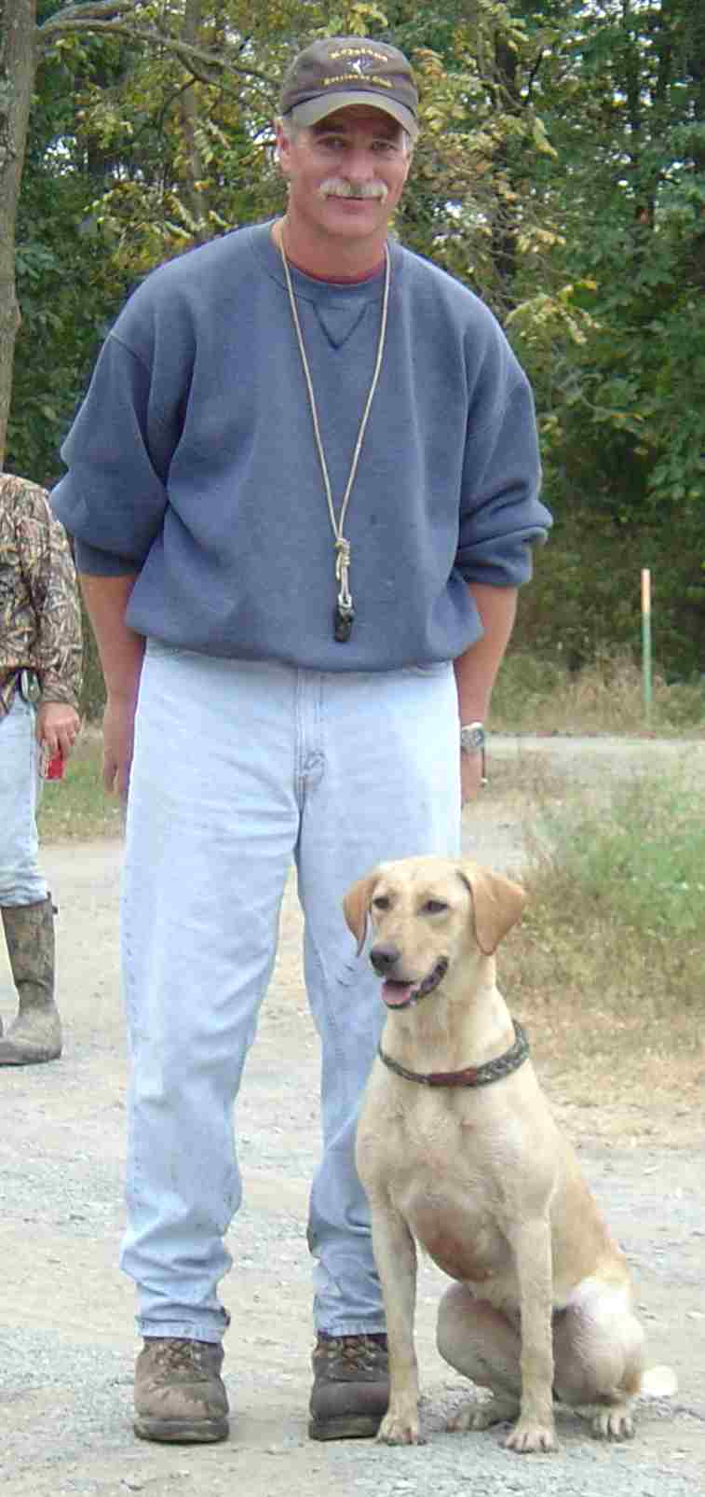

NPRC's Jim Podlaseck and Max NPRC's Sonny Jones and Tess

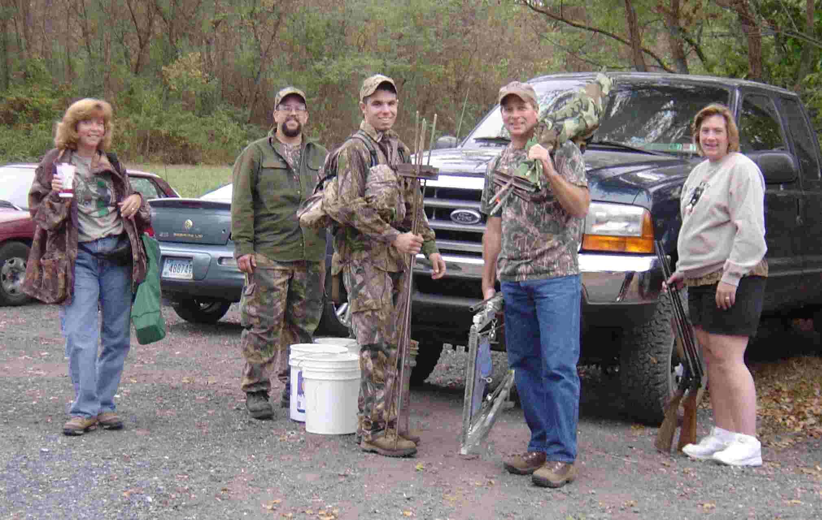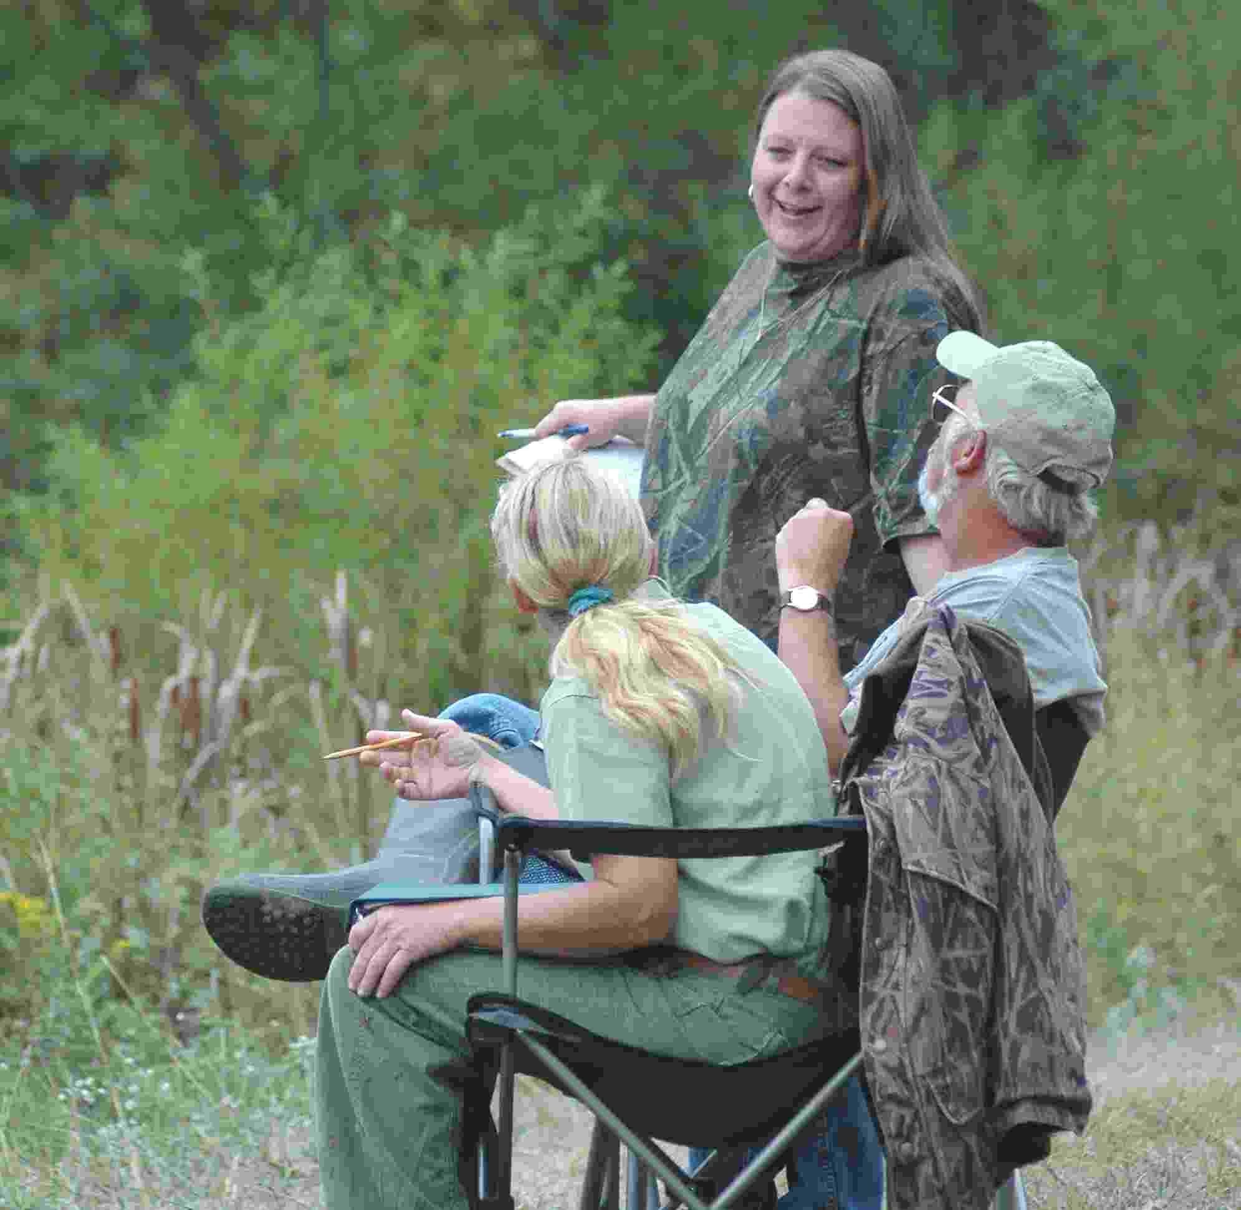
Started I workers at the end of a long day. (Photo courtesy Jackie Lutskus) With books closed, Senior judges Paul Young
and Maggie Rathje discuss with Marshall Val Plewa how long it will take The Goon to circumnavigate the island adjacent to their water blind. The final total was 7:30 and 26 whistles. (Photo courtesy Betty Schmidt)

NORTHERN PIEDMONT RETRIEVER CLUB
1278 Battery Avenue
Baltimore, Maryland 21230-4302

